EXPERIMENT – 4 String and Block Data Operations Using 8086 Microprocessor

Objectives
1. To transfer a block of bytes using MOVSB with the REP prefix, including an overlapping block move
controlled by the direction flag.
2. To compare two strings using CMPSB with the REPE prefix and locate the first mismatch.
3. To search a string for a character using SCASB with the REPNE prefix and count its occurrences.
4. To process a string element by element using LODSB and STOSB (lower-case to upper-case
conversion).

Program A – Block Transfer with REP MOVSB

1000 CLD
1001 MOV SI, 3000H
1004 MOV DI, 3100H
1007 MOV CX, 000BH
100A REP MOVSB
100C HLT

Output
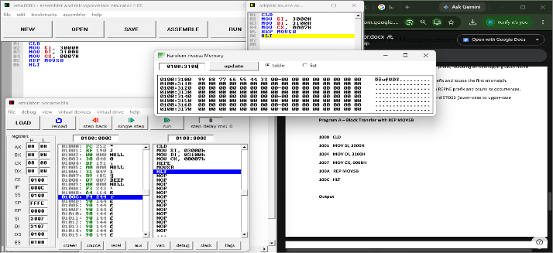
Program B – String Comparison with REPE CMPSB

1100 CLD
1101 MOV SI, 3200H
1104 MOV DI, 3210H
1107 MOV CX, 0003H
110A REPE CMPSB
110C JNE DIFF
110E MOV BYTE PTR [3220H], 00H
1113 HLT
1114 DIFF: MOV AX, 0003H
1117 SUB AX, CX
1119 MOV [3220H], AL
111C HLT
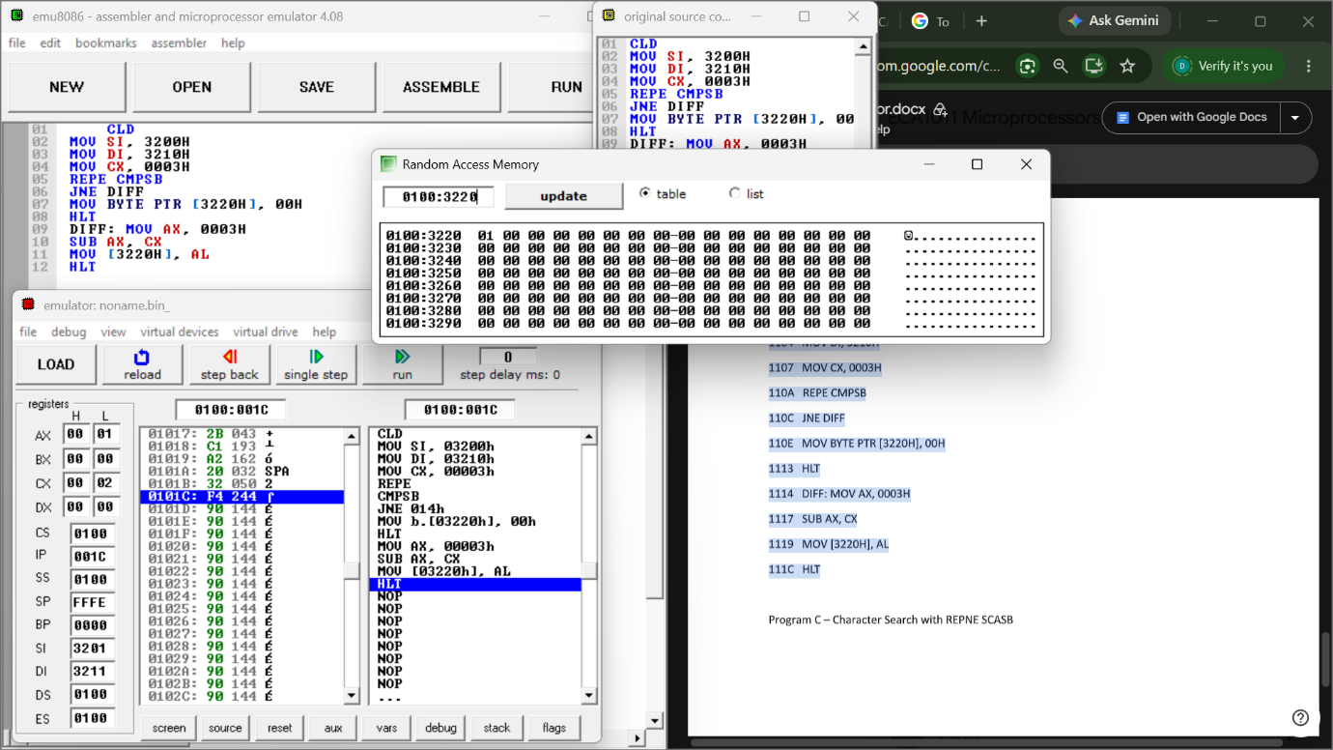

Program C – Character Search with REPNE SCASB (start address 1200H)
Algorithm
1. Clear DF; point DI to the string; CX = length; AL = character; clear the counter and
position.
2. Execute REPNE SCASB; if not found, go to step 4.
3. Increment the count; record the first position (DI − start); if CX ≠ 0 repeat step 2.
4. Store the count and the first position; halt.
Program / Coding Table

MOV DI,3300H
MOV CX,000CH
MOV AL,41H
MOV BL,00H
MOV DX,0000H
AGAIN:REPNE SCASB
JNE DONE
INC BL
CMP DX,0000H
JNE SKIP
MOV DX,DI
SUB DX,3300H
SKIP:JCXZ DONE
JMP AGAIN
DONE:MOV [3310H],BL
MOV [3311H],DL
HLT

OUTPUT

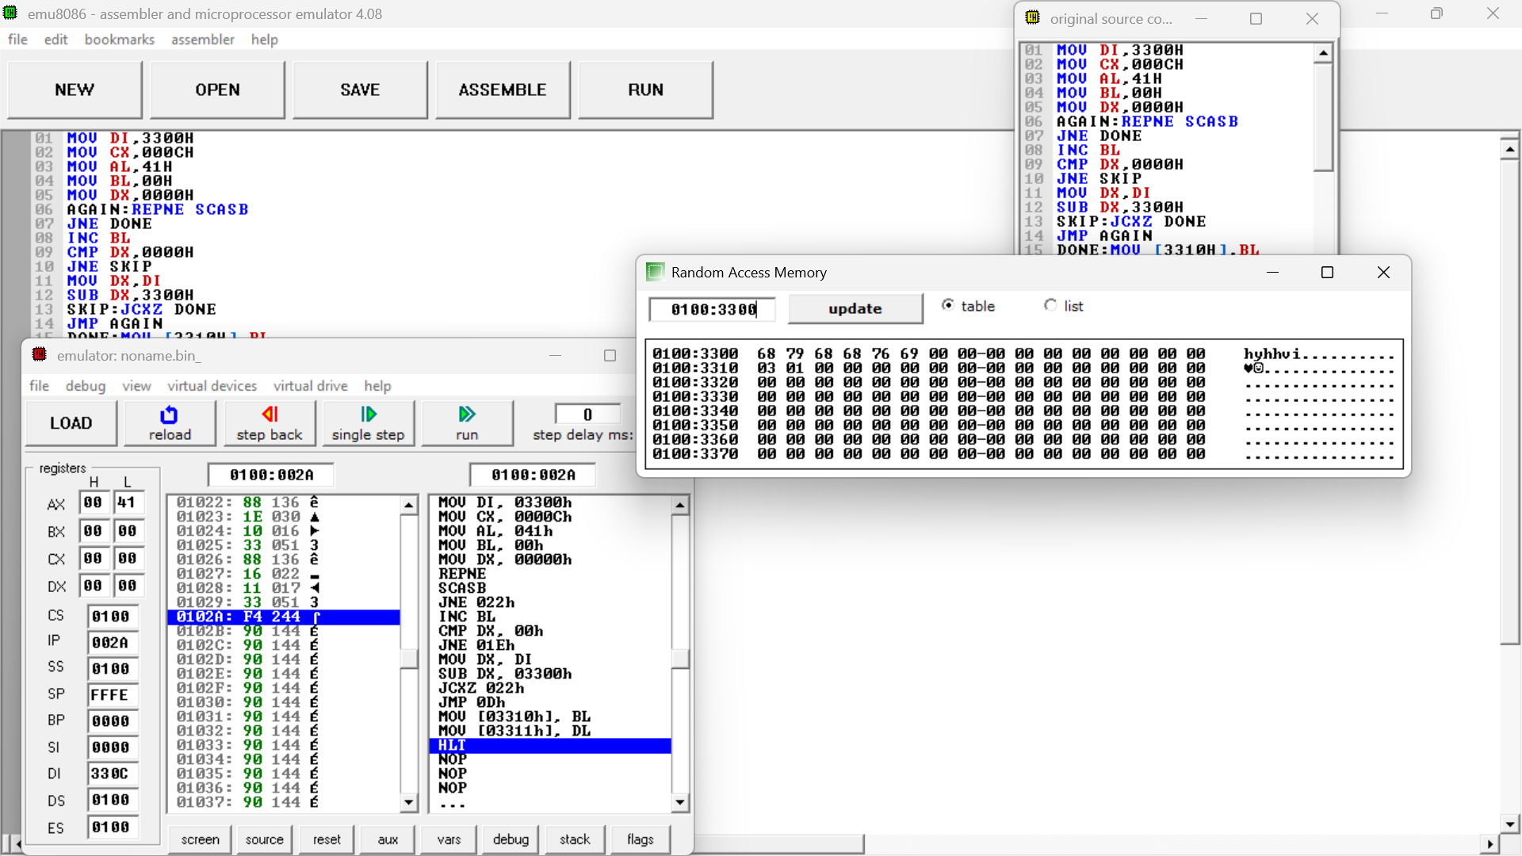

Program D – Lower-case to Upper-case Using LODSB / STOSB (start address 1300H)
Algorithm
1. Clear DF; point SI to the source and DI to the destination; CX = length.
2. LODSB loads a character; if it lies between 61H and 7AH subtract 20H.
3. STOSB stores the character; LOOP until CX = 0.
4. Halt.

PROGRAM

MOV SI,3400H
MOV DI,3420H
MOV CX,000AH
CLD

NEXT: LODSB
CMP AL,61H
JB STORE
CMP AL,7AH
JA STORE
SUB AL,20H

STORE: STOSB
LOOP NEXT

HLT
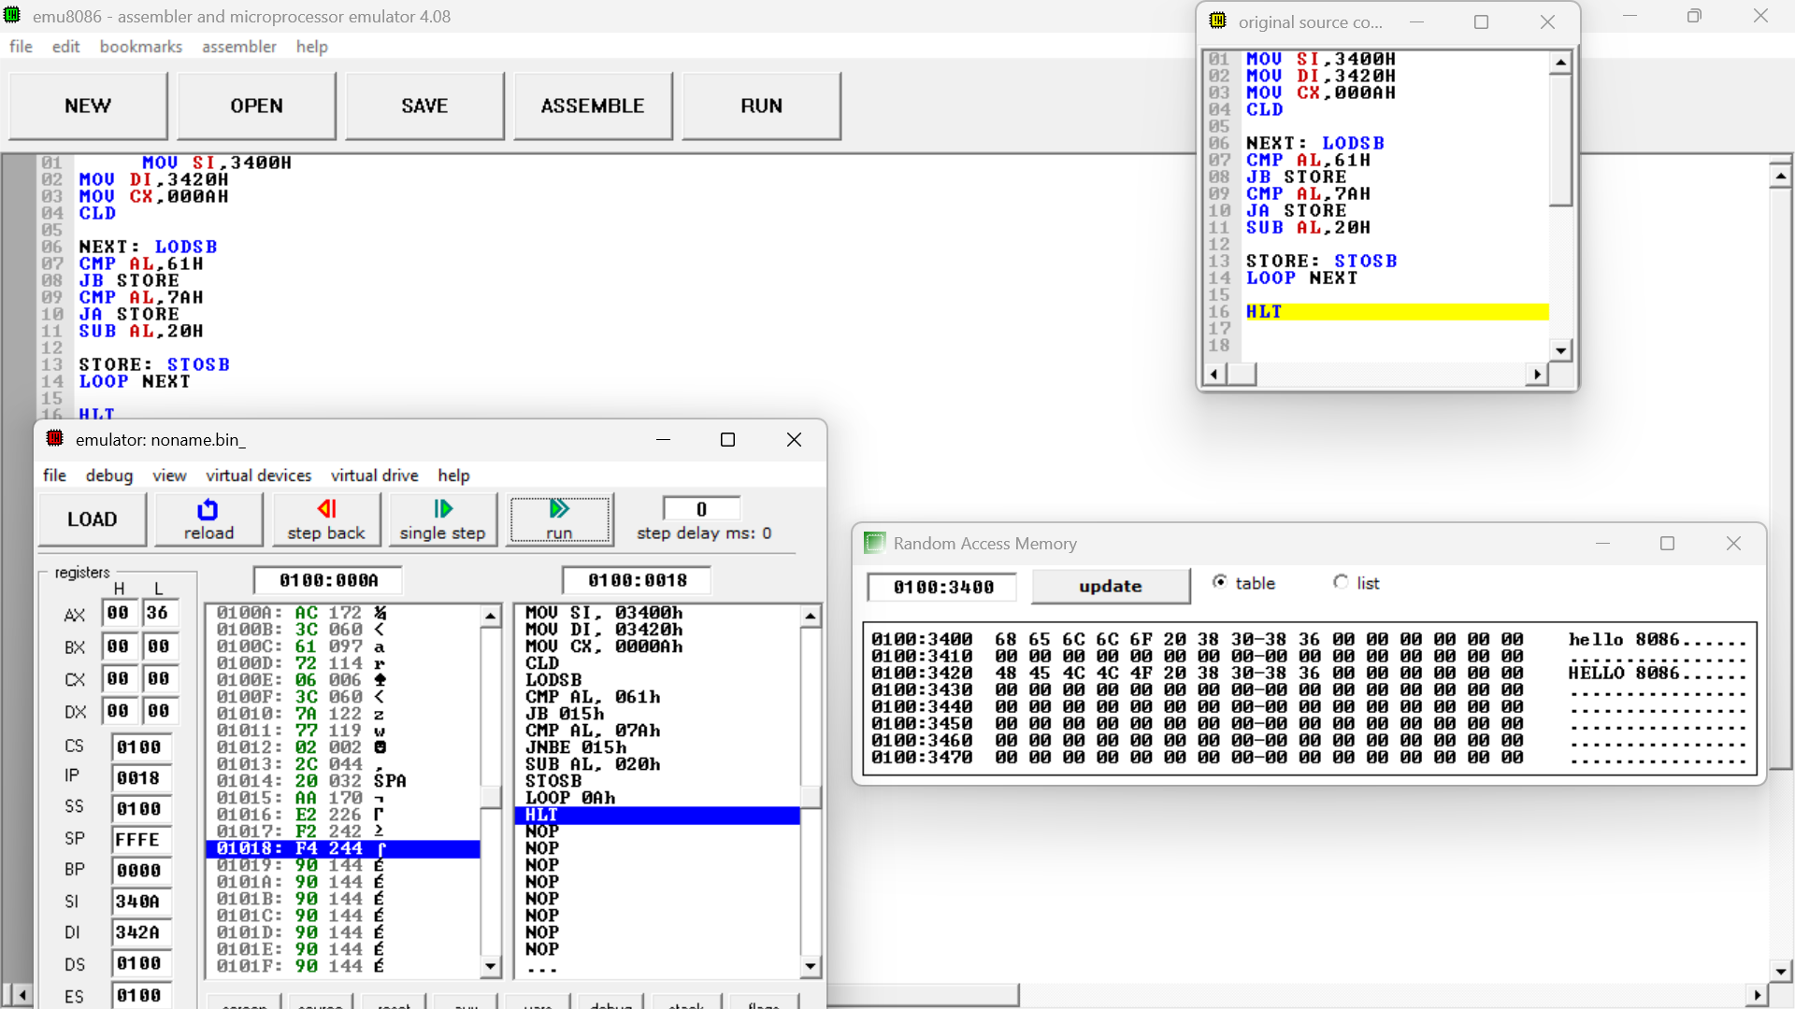

RESULT:
Thus, the 8086 microprocessor string and block data operations were successfully executed. Block transfer using REP MOVSB, overlapping block movement using the direction flag, string comparison using REPE CMPSB, character searching using REPNE SCASB, and lowercase-to-uppercase conversion using LODSB and STOSB were performed successfully, and the expected outputs were obtained in the specified memory locations.

